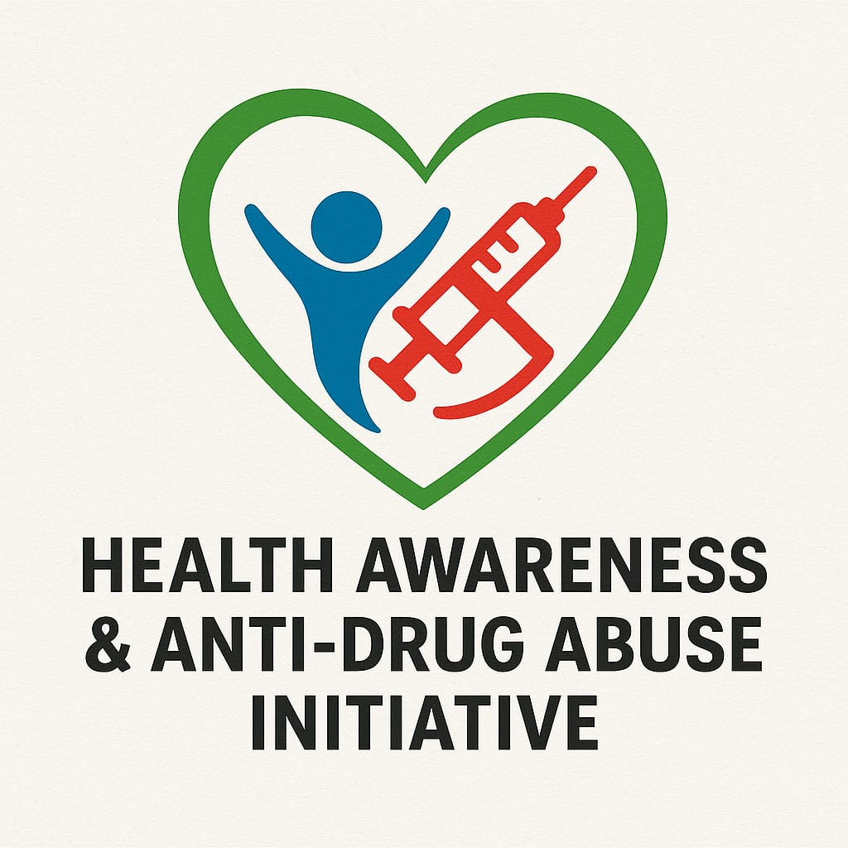

HEALTH AWARENESS & ANTI-DRUGS INITIATIVES OFFICIAL GROUP (HAADI) (Recovery is Possible)

Detailed Organization Profile

Contact Information
Head Office Address: LA Madugu Plaza, State Lowcost, Gombe
Phone: +234 706 186 5850, 0808 427 7233, 08105392025
Email: dfsinigeria@gmail.com info@haadifoundation.com
Website: www.haadifoundation.com

Detailed Organization Profile
The Health Awareness & Anti-Drugs Initiatives Official Group (HAADI) is a non-governmental and non-profit organization dedicated to promoting public health, drug-free living, and community resilience across Northeastern Nigeria and the entire country. Formerly known as the Drugs Free Society Initiative (DFSI), HAADI has expanded its mission and organizational scope to include broader health awareness, community sensitization, and collaboration with relevant governmental and non-governmental organizations.
Headquartered in Gombe State, HAADI delivers structured interventions focused on drug abuse prevention, health awareness, community sensitization, support services, and referral pathways for rehabilitation. Our programs are designed to address the unique social, economic, and security realities of the region, including the effects of insurgency, violence, displacement, and related trauma.
HAADI works closely with traditional rulers, religious institutions, youth organizations, health facilities, and partners to create sustainable community-driven solutions. Our central goal is to build a healthier society free from drug abuse and preventable illnesses.

HEALTH AWARENESS & ANTI-DRUGS INITIATIVES (HAADI)

Business Proposal
HAADI is a public health-focused NGO promoting drug abuse prevention, awareness, counseling, and community sensitization. The proposal outlines HAADI’s mission to expand outreach, strengthen partnerships, and increase access to support services across Nigeria.

Website About Us
HAADI is dedicated to promoting a drug-free society through awareness campaigns, youth programs, counseling, and collaboration with government and NGOs.

One-Page Organisation Profile
Mission: Promote drug-free living.
Vision: A healthier, drug-free society.
Core Values: Compassion, Integrity, Empowerment, Collaboration.
Services: Awareness campaigns, youth programs, counseling, rehabilitation referrals, advocacy.

Mission and Vision

Mission
To promote a healthier and drug-free society by raising awareness, providing prevention-focused sensitization, offering culturally sensitive support, and collaborating with stakeholders to address drug abuse and other related community health issues.

Vision
A society where individuals, families, and communities are empowered with the knowledge and support needed to live free from the destructive impact of drug abuse and preventable health challenges.

Core Values
Compassion:
We approach every individual with empathy, understanding the unique socioeconomic and security challenges within our communities.
Integrity:
We uphold transparency and accountability in all our operations to foster trust and credibility.
Empowerment:
We enable individuals and youth to make informed decisions that promote healthy, drug-free living.
Collaboration:
We partner with government agencies, NGOs, community leaders, and institutions to strengthen and scale our interventions.
Cultural Sensitivity:
We design and deliver all programs with respect for the cultural and religious backgrounds prevalent across Northern Nigeria.
Community Ownership:
We actively involve community members and stakeholders to ensure sustainability and long-term impact.

Core Services
HAADI offers a comprehensive range of programs and services adapted to the realities of Northeastern Nigeria and nationwide.

1. Community Awareness & Sensitization Campaigns
- Large-scale public sensitization in markets, schools, religious centers, and community gatherings.
- Local radio programs and Hausa-language outreach to maximize reach.
- Partnerships with traditional and religious leaders for message amplification.
- Health-focused campaigns addressing drug abuse, mental health, and public health issues.

2. Youth-Focused Drug Prevention Programs
- School outreach programs focusing on peer pressure, life skills, and positive choices.
- Sports, recreation, and community activities as alternatives to drug use.
- Mentorship programs featuring respected community figures and role models.

3. Support, Counseling & Community Reintegration
- Initial counselling for individuals seeking help with drug-related challenges.
- Support groups for recovering individuals and their families.
- Social reintegration programs promoting acceptance and community support.
- Confidential and culturally sensitive approaches suited to local realities.

4. Rehabilitation Referral & Follow-up Support
- Linkages with rehabilitation centers within and outside Northeastern Nigeria.
- Assistance in referral processes, transportation, and follow-up guidance.
- Reintegration support for individuals completing rehabilitation programs.

5. Advocacy & Policy Engagement
- Advocacy for improved public health and anti-drug policies.
- Engagement with state and local governments to strengthen rehabilitation and prevention systems.
- Promotion of community-centered solutions to drug abuse and related health issues.

6. Partnerships & Collaboration
HAADI actively collaborates with:
- Governmental agencies (health, youth, security).
- Local and international NGOs.
- Health facilities and rehabilitation centers.
- Religious and traditional institutions.
Our work emphasizes collaboration and partnership as essential drivers of sustainable change.

Funding and Sustainability
Primary Funding:
Contributions and membership support.
Supplementary Funding:
Partnerships with government agencies and development stakeholders.
Additional Resources:
Support from local businesses, philanthropic contributions, community fundraising, and emerging social enterprises aligned with HAADI’s mission.

Community Impact Goals
HAADI is committed to:
- Reducing drug abuse prevalence among youth nationwide.
- Improving access to health literacy and prevention-focused education.
- Empowering communities to take ownership of drug-free initiatives.
- Strengthening family and community resilience in environments affected by insecurity.
- Building a healthier, more informed, and more productive society.

FULL BUSINESS PLAN

Health Awareness & Anti-Drugs Initiatives Official Group (HAADI)

Executive Summary
HAADI is a non-governmental organization dedicated to reducing drug abuse, promoting public health awareness, and strengthening community resilience across Nigeria. This business plan outlines the organization’s operational strategy, goals, programs, funding model, and sustainability framework for the next five years.

Organizational Background
HAADI evolved from the former Drugs Free Society Initiative (DFSI) to expand its mission toward broader public health and anti-drug sensitization. Based in Gombe State, HAADI operates across Northeastern Nigeria with strategic plans for national outreach.

Problem Statement
Nigeria faces increasing drug abuse among youth, insecurity, poverty, trauma, and limited awareness. Communities lack structured counseling, rehabilitation referral systems, and consistent sensitization.

Vision, Mission, and Core Values
Vision: A drug-free, health-conscious, and resilient society.
Mission: To promote public health and drug abuse prevention through sensitization, counseling, partnerships, and community-based interventions.
Core Values: Compassion, Integrity, Empowerment, Collaboration, Cultural Sensitivity, Community Ownership.

Goals and Objectives
Short-term Objectives:
- Organize 100 community sensitization programs yearly.
- Strengthen partnerships with rehabilitation centers.
- Launch counseling and support groups in at least 10 communities.
Long-term Objectives:
- Establish a HAADI Community Health Center.
- Implement nationwide drug abuse awareness programs.
- Build a digital health and sensitization platform.

Programs and Services
• Community sensitization campaigns
• School and youth programs
• Counseling and referral services
• Rehabilitation linkage and reintegration
• Advocacy and policy engagement
• Media outreach (radio, TV, social platforms)

Market & Community Analysis
HAADI serves youth, families, displaced persons, schools, religious institutions, and communities facing insecurity. Drug abuse cases in Nigeria have risen to nearly 15 million users; thus, HAADI’s interventions fill a critical gap in prevention and awareness.

Operational Plan
• Head office in Gombe State
• Trained volunteers and health educators
• Partnerships with clinics and rehabilitation centers
• Deployment of mobile sensitization teams
• Annual training for staff and volunteers

Organizational Structure
Board of Trustees
Executive Director
Program Managers
Field Officers
Counselors & Volunteers
Finance & Admin Unit

Monitoring & Evaluation (M&E)
• Data-driven reporting
• Participant attendance and feedback
• Community impact assessments
• Quarterly program evaluation
• Annual performance review

Risk Analysis
Potential Risks:
- Insecurity in certain regions
- Funding instability
- Stigmatization of participants
Mitigation:
- Collaboration with security agencies
- Diversified funding
- Community sensitization strategies

Financial Plan
Estimated Annual Budget:
• Awareness Programs – ₦15,000,000
• Counseling & Training – ₦10,000,000
• Administration – ₦8,000,000
• Media Campaigns – ₦12,000,000
• Logistics – ₦5,000,000
Total: ₦50,000,000 Annually

Funding Sources
• Contributions from members
• State government support
• NGO partnerships
• Donor agencies (local and international)
• Community fundraising & CSR programs
• Social enterprise initiatives

Sustainability Strategy
• Building long-term donor relationships
• Developing income-generating programs
• Strengthening community ownership
• Establishing a training and research center

Conclusion
This business plan positions HAADI as a leading organization in health awareness and drug abuse prevention. Through collaboration, strategic programming, and sustainable practices, HAADI aims to transform communities across Nigeria.

ORGANISATONAL STRUCTURE

